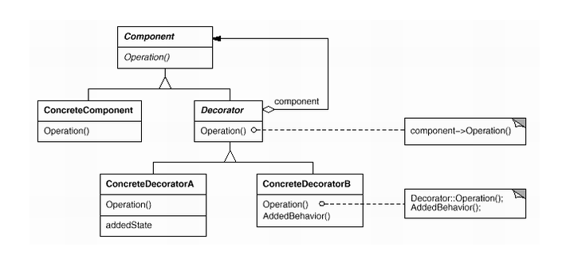

Decorator pattern:

Component:Window

ComcreteComponent:SimpleWindow

Decorator:WindowDecorator

ConcreteDecoratorA:HorizontalScrollBarDecorator

ConcreteDecoratorB:VerticalScrollBarDecorator